TECNAM P2010
EMERGENCY PROCEDURES & PREFLIGHT CHECKLIST
*This is to be used as a REFERENCE ONLY, it is not a substitute for the Airplane Flight Manual.
*Refer to AFM/POH for amplified procedures. User assumes all risk of use in using this product. User consents to and understands that American Flight Schools bears no liability for the use of this product.

ENGINE FIRE DURING START
- Mixture …………………………….… CUT OFF
- Fuel Selector ……………………………… OFF
- Ignition key ……………………………….. OFF
- Fuel pump………………………………….. OFF
- MASTER SWITCH ………………………. OFF
- Aircraft evacuation……............ PERFORM

ENGINE POWER LOSS DURING TAKEOFF
If engine fails before rotation: ABORT TAKE OFF
- Throttle Lever ………………………...….IDLE (fully out and hold)
- Mixture ………………………………. CUT OFF
- Brake …………………………. AS REQUIRED
With aircraft stopped
- Ignition key…………………………….…... OFF
- Fuel Selector…………………………….…..OFF
- Electrical fuel pump ...…………….…… OFF
- Generator & Master Switches…….… OFF
- Parking Brake…………………… ENGAGED
- Aircraft Evacuation…………… PERFORM ………………………………………..if necessary

ENGINE POWER LOSS IN FLIGHT
If engine fails immediately after becoming airborne:
- Abort on the runway if possible.
In case low altitude precludes a runway stop and / or engine restart:
INFLIGHT ENGINE RESTART
  - Airspeed ………….....……………………85KT
  - Find a suitable place to land safely.
  - Master switch ………………….… Check ON
  - Fuel pump …………………………..………. ON
  - Fuel quantity indicator ………….. CHECK
  - Fuel Selector …………...…. SWITCH TANK
  - Throttle Lever ….. Min 1cm. above IDLE
  - Propeller Lever…………..….. Full forward
  - Mixture ………………………...…… FULL rich
  - Throttle lever …………… SET as required
If restart unsuccessful
- Throttle Lever…………………………… IDLE (fully out and hold)
- Mixture……………………………..… CUT OFF
- Brakes………………………….…. As required
With aircraft stopped
- Fuel Selector…………………………… OFF
- Electrical fuel pump………………… OFF
- Ignition key…………………………….. OFF
- Generator & Master Switches……… OFF
- Parking Brake………………….… ENGAGED
- Aircraft Evacuation……………. PERFORM ………………………………………..if necessary

POWER OFF LANDING
- Flaps……………………………………………. UP
- Airspeed ………….... ESTABLISH VGLIDE
- Radio ………………………………… Transmit MAYDAY giving location and intentions
- Transponder ……………………………. 7700
- If off airport, ELT ………….……………… ON
Find a suitable place to land safely, plan to approach it upwind
- Throttle Lever ………………………..…. IDLE
- Mixture …………………………..…… CUTOFF
- Fuel Selector …………………….………... OFF
- Ignition key …………………..……………. OFF
- Fuel pump …………………………….……..OFF
- Seat belts ………….…. Tightly FASTENED
When landing is assured:
- Flaps ……………………...…… AS REQUIRED
- Generator and Master switches ..…. OFF

FIRE IN FLIGHT
  - Cabin heat and defrost …….... BOTH OFF
  - Mixture …………………………..…….CUTOFF
  - Fuel Selector …………………………........ OFF
  - Throttle Lever ……….... FULL FORWARD
  - Ignition key …………………………..….... OFF
  - Electrical fuel pump ………………..….. OFF
  - Emergency……………………....…...Declared
  - Master Switches ……………………….... OFF
  - Cabin ventilation …………………...… OPEN
  - Land …………………………………Power OFF

LOSS OF FUEL PRESSURE
  - Electric fuel pump………………………... ON
  - Fuel selector valve………………….... Select ………….opposite fuel tank if NOT empty
  - Fuel quantity …………………….…... CHECK

ELECTRICAL FAILURES
- MASTER SWITCH …………………….…..OFF
- Generator Switch ……………………..….OFF
- MASTER SWITCH ………………………....ON
- Generator Switch ………………………….ON
If failure persists Land as soon as possible
- Effected C/B………………………………...Pull

PROPELLER OVERSPEED
- Throttle Lever ……………REDUCE power
- Propeller Lever …………. ..Decrease RPM
- Mixture Lever ……………..…...As required
- RPM indicator ……………………….. CHECK
If it is not possible to decrease propeller rpm, land as soon as possible

SPIN RECOVERY (PARE)
- THROTTLE………………..……..…………IDLE
- AILERONS………………..…………NEUTRAL
- RUDDER……………..……..FULL OPPOSITE
(to direction of rotation)
- CONTROL WHEEL…..…FULL FORWARD
- RUDDER………..…………….…..….NEUTRAL
(when rotation stops)
- CONTROL WHEEL…………AS REQUIRED
(to smoothly regain level flight altitude)

PREFLIGHT CHECK
COCKPIT
- Aircraft documents ………...……...ARROW
- Weight and balance ………….…..calculate
- Breaker ………………………..……..…….all IN
- Safety belts …..………..….check condition
- Ignition key …..………OFF, key extracted
- Master switch …………………….…………ON
- Voltmeter …….….check within the limits
- Lights …..……all ON, check for operation
- Acoustic stall warning .........................................check for operation
- Master switch ……………..………...…….OFF
- Baggage ……..…..….Check for equipment

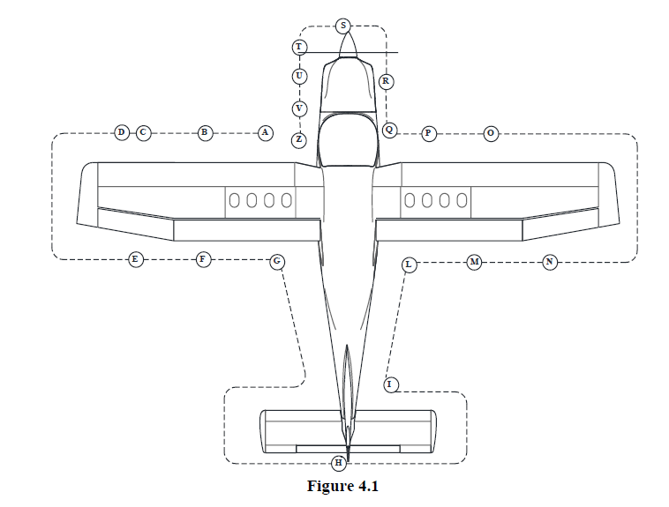

AIRCRAFT WALK-AROUND
- Left fuel filler cap……..….………….…Check
- Pitot tube ………………...…………….…Check
- Left side leading edge and wing skin ………………..…………………………….…Check
- Left strobe light ….....................………Check
- Left aileron, hinges and LH tank vent line…………...………………………………Check
- Left flap and hinges………...…………Check
- Left main landing gear……..……..…Check
- Stabilator, tab and rear light…...….Check
- Vertical tail and rudder ………..……Check
- Right main landing gear…...……..…Check
- Right flap and hinges……...……….…Check
- Right aileron, hinges and RH tank vent line……………...……………………………Check
- Right strobe light, leading edge and wing skin………..……………………...…Check
- Stall indicator switch …………..……Check
- Right fuel filler cap …………..…….…Check
- Nose wheel strut and tire/RH static port……………..………………………...…Check
- Propeller and spinner condition …………………………..………………….…Check
- Check the engine cowling surface conditions, then open engine inspection doors…..……………………Check
- Engine cowling doors …………........CLOSE
- Landing/taxi light and LH static port ……………..……………………………….…Check
- Tow bar and chocks …...........…..REMOVE stow on board pitot, static

